**Lesson3 APP2:**

**Change the Volume Size of an Instance**

Creating the new volume which we want to add to an instance and clicking on **create volume**

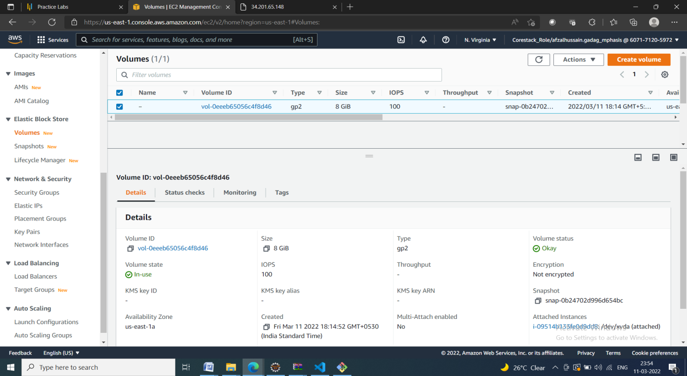

Validating the Availability zone of the EC2 instance with which you want to add volume

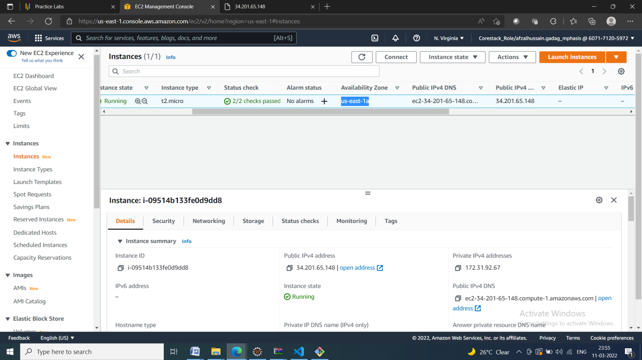

Providing type, size, availability zone, and snapshot name on the **create volume** tab

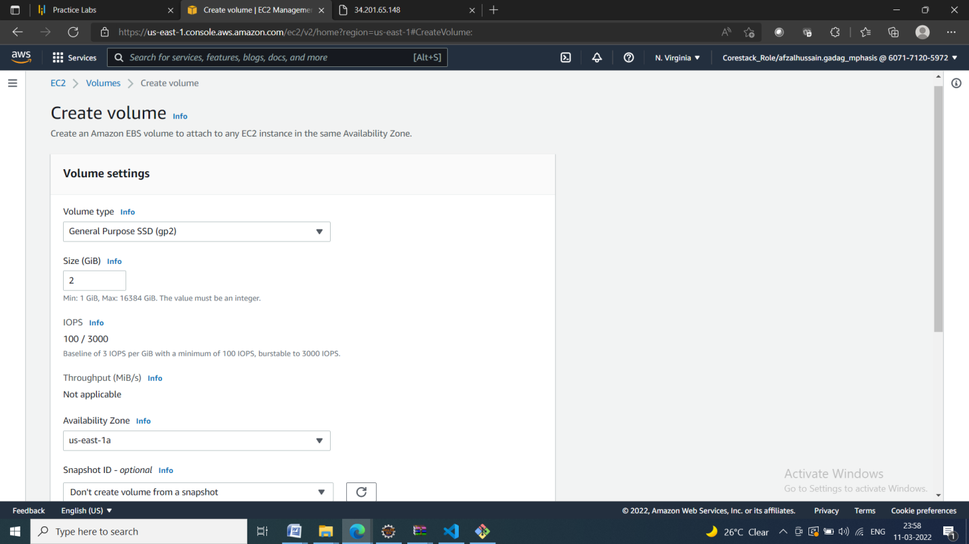

Selecting newly created volume and clicking on the action to attach the volume to the instance

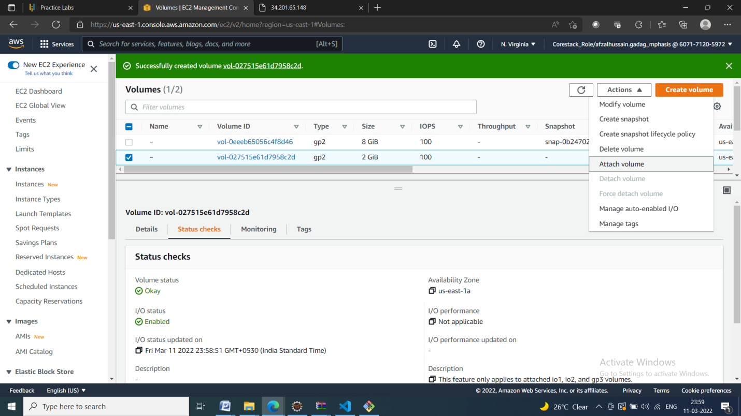

Selecting the instance of the same availability zone and attaching the volume in pop

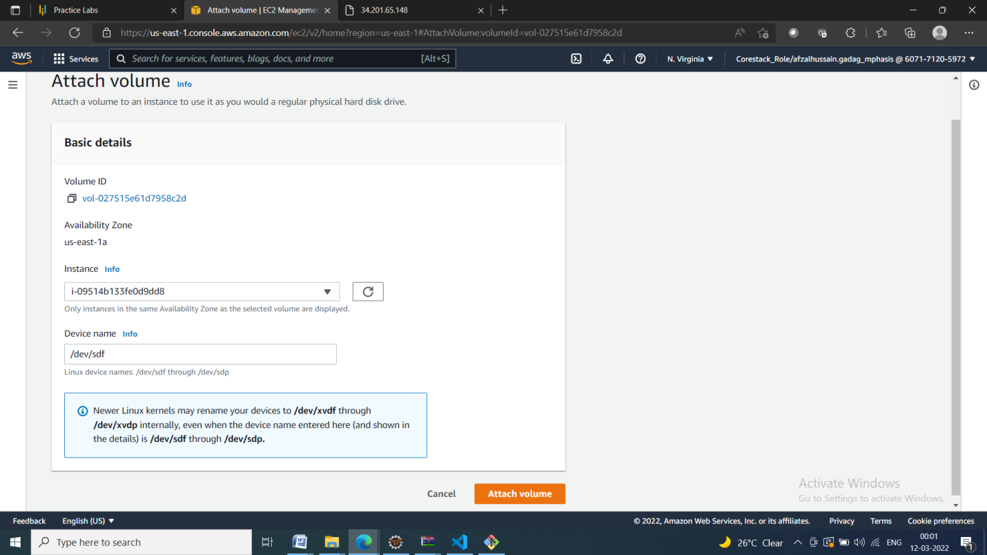

Verifying the instance by adding one more device to the block device

